Morrison County Drop In Center
November 2026
Pam’s hours are Monday – Friday 9:00am – 2:00pm. If you need her any other time, please put a note in her door she will get back to you as soon as possible.
If you have any topics you would like us to cover in groups, please let us know as we are always looking for new ideas!

Nov. 1st Vikings vs Lions
Nov.9th Vikings vs Bills
Nov. 15th Vikings vs Packers
Nov. 22nd Vikings vs 49ers
Nov. 29th Vikings vs Falcons

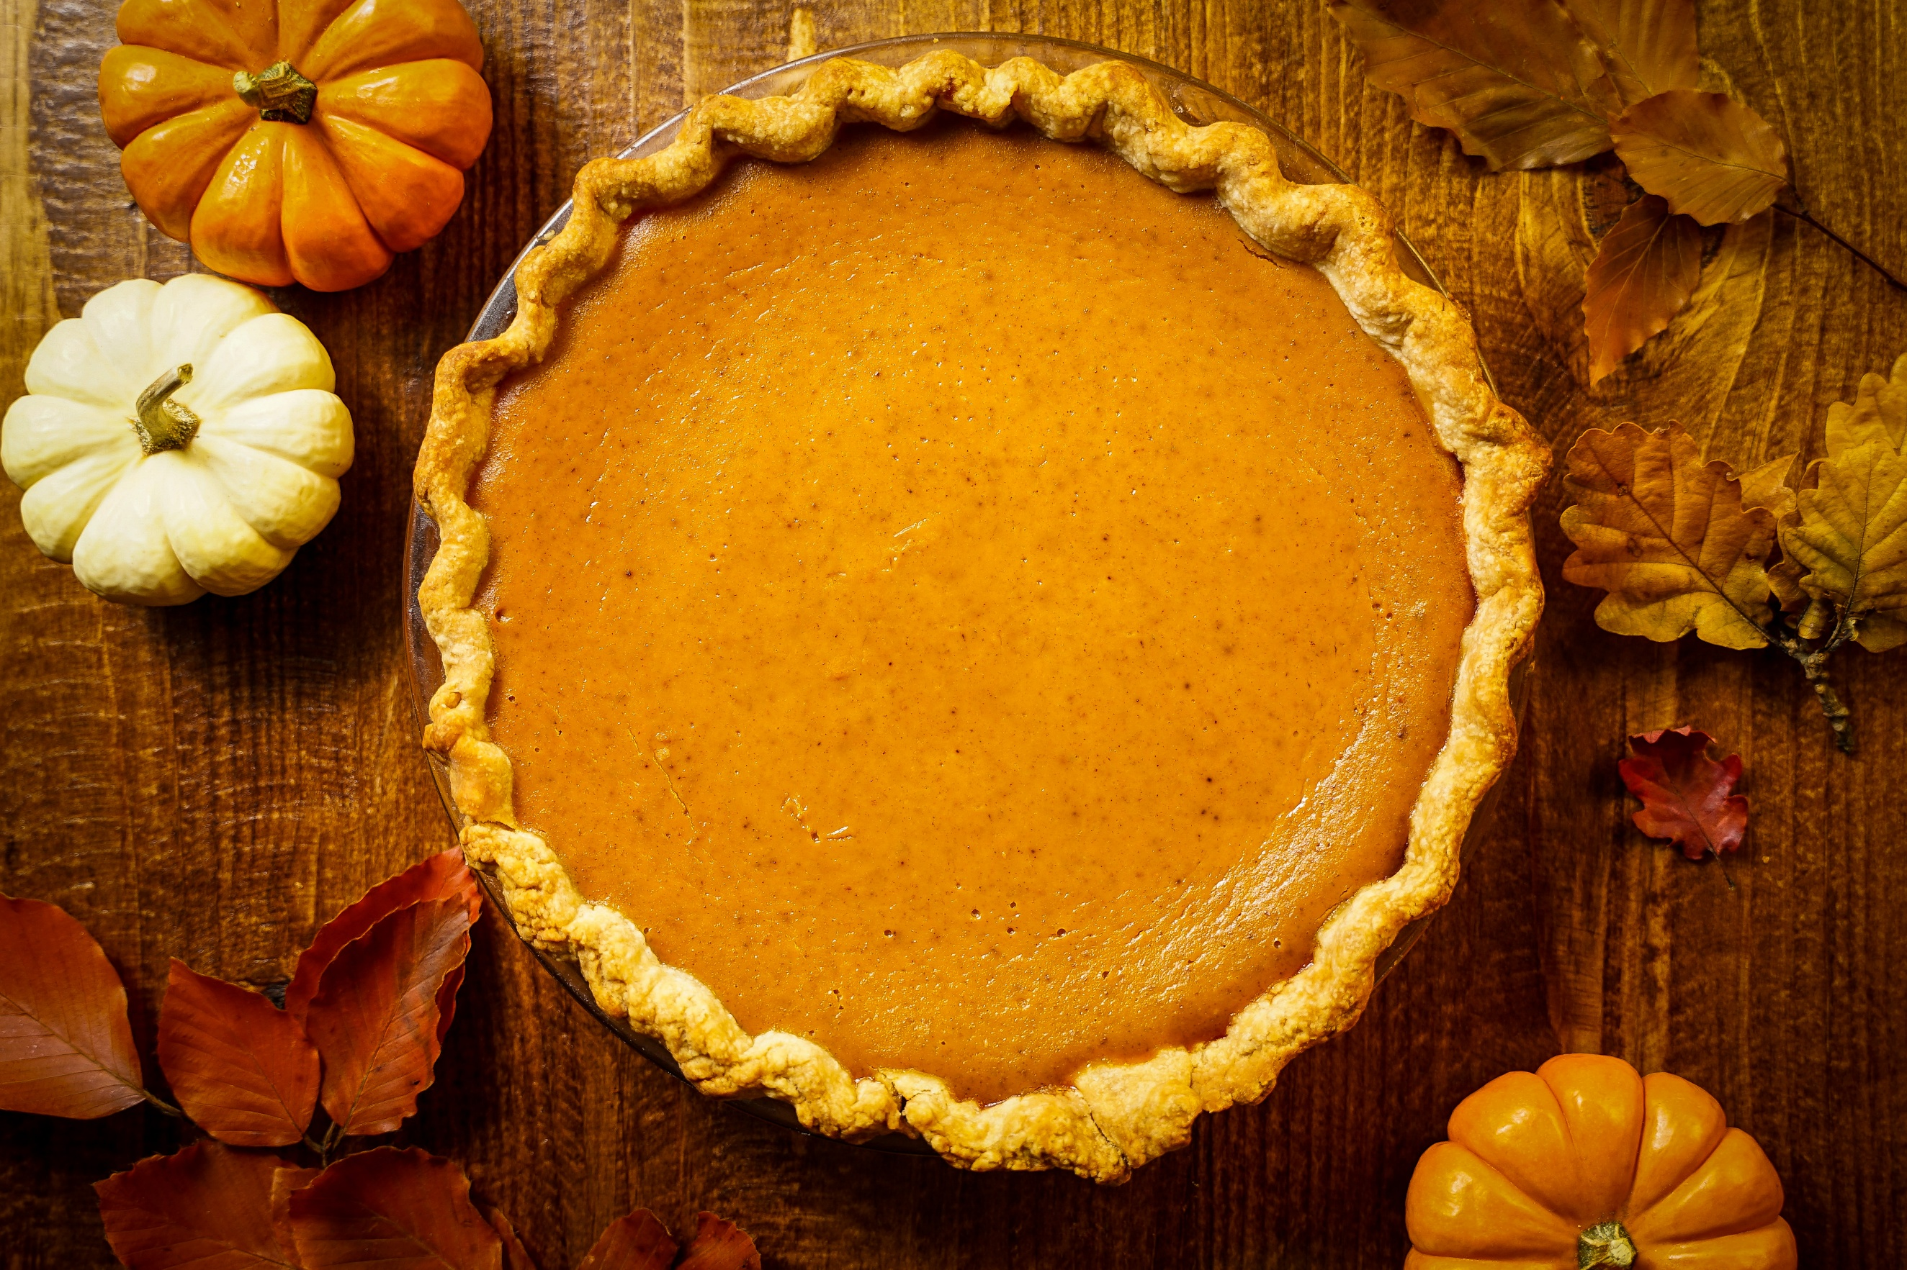

We have craft group every Wednesday from 10-?. Come and show/teach us a new craft!

Peer Meeting
We will be having a peer meeting on the 11th at 11:40am please come join us as we have a lot to talk about. See you here.
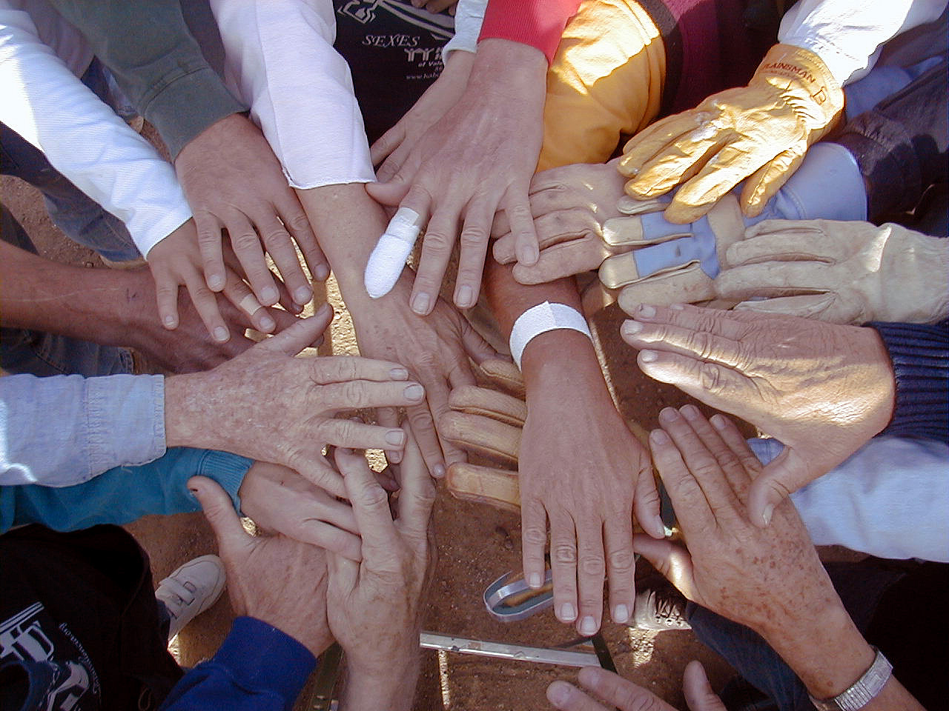

11 | 11:40am Peer meeting
11 | 12-lpm BINGO
17 | Warm your soul
25 | Pot Luck
26 CLOSED
27 CLOSED

